SPIRIO

The STEINWAY & SONS SPIRIO is the world’s finest *high resolution player piano*. A masterpiece of *artistry* and *engineering* in your home, SPIRIO enables you to enjoy performances captured by great pianists — played with such nuance, power and passion that it is utterly *indistinguishable* from a live performance.

### available MODELS

* 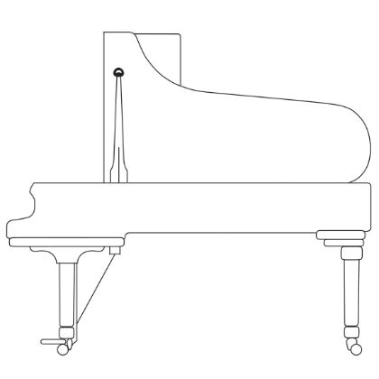

#### Model B

As a Model B, this SPIRIO is a magnificent 6' 11" (211 cm) grand piano, often referred to as the “perfect piano.” It’s a wonderfully balanced and versatile instrument that does extremely well in intimate settings, teaching studios, and mid-sized venues. Complimentary iPad® included.

LENGTH — 6' 101/2" (211 cm)  
WIDTH — 58" (148 cm)  
WEIGHT — 760 lbs (345 kg)

* 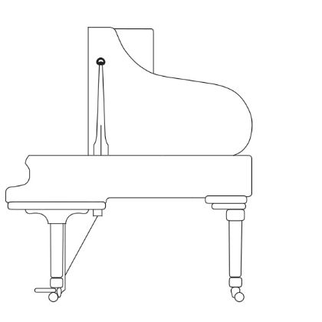

#### Model M

At 5' 7" (170 cm) in length, the Model M SPIRIO features a rich tone and responsive action that is found not only in a great many homes, but in many schools of music and conservatories as well. Called the “Medium” grand, there is nothing medium about the sound from this instrument. Complimentary iPad® included.

LENGTH — 5' 7" (170 cm)  
WIDTH — 573/4" (147 cm)  
WEIGHT — 560 lbs (275 kg)

‘The STEINWAY SPIRIO is as close as one can get to hearing private recitals by world-class musicians.’

—THE TELEGRAPH (LONDON)